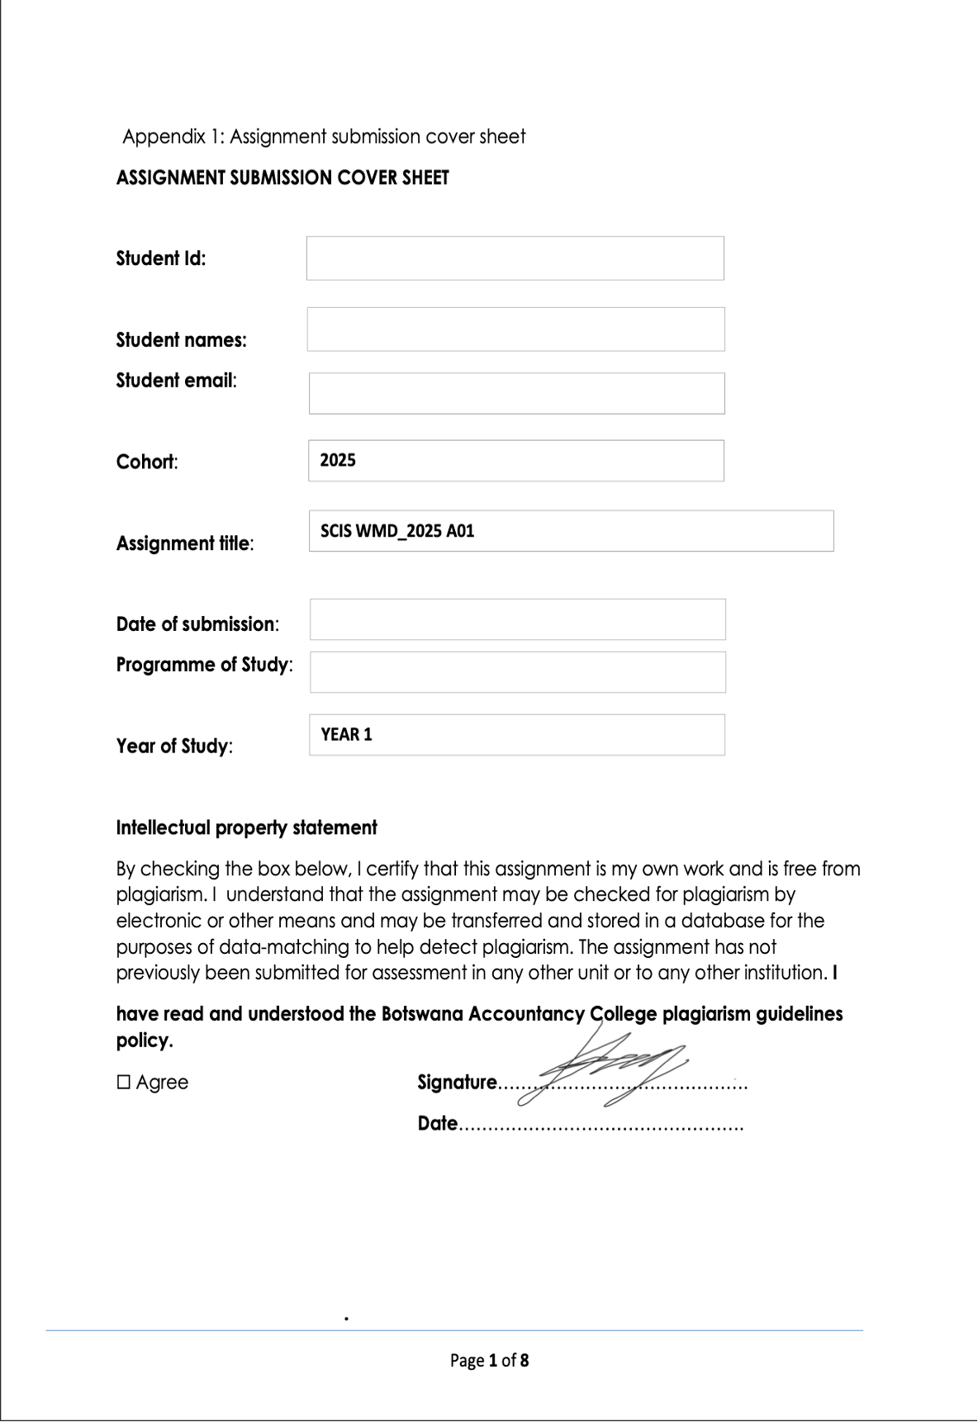



19/09/25

Year 2

CSE

OOAD Assignment Part A

19/09/2025

cse24-107@thuto.bac.ac.bw

Katlego Renee Baitirile

cse24-107

**Requirements Elicitation**

**Functional Requirements**

* Following a consultation with the client, the core functional requirements of the banking system have been defined. The system must serve as a tool for bank tellers to manage customer accounts securely and efficiently. The key functions are:
* The system must allow a teller to open an account for a Customer, who can be either an Individual or a Company/Organization.
* The system must enforce distinct business rules for each account type:
* **Savings Account**: Must not allow any withdrawals. The user interface must not present a withdrawal option for this account type.
* **Investment Account**: Must require a minimum initial deposit of BWP 500.00. The system must prevent the account creation if this minimum is not met.
* **Cheque Account**: Requires the customer's company name (as proof of employment for individuals).
* The system must maintain a transaction history for each account, recording at minimum the date, transaction type (deposit/withdrawal), amount, and the resulting balance.
* The system must allow a single customer to have multiple accounts (e.g., one Savings and one Investment account).

**Non-Functional Requirements**

* The client emphasized that the primary quality attributes of the system should be usability and logical design, in line with the module's focus on Object-Oriented principles.
* **Usability:** The user interface must be intuitive and user-friendly, with a logical layout of buttons and controls to ensure tellers can perform tasks efficiently.
* **Security**: Basic security will be implemented through user authentication using a username and password for system access. Advanced security measures like data encryption are out of scope for this project.
* **Performance:** Given the expected minimal dataset (approximately 10 records for demonstration), performance is not a primary concern beyond ensuring the application runs without unnecessary delay.

**Appendix A: Requirements Elicitation Interview Record**

**Interview Metadata**

* Date: 17/09/2025
* Attendees:
  + Interviewer (Systems Analyst): Katlego Renee Baitirile
  + Client (Stakeholder): Kentsenao Baseki, representing Bank Management
* Purpose of Meeting: To elicit and clarify the functional and non-functional requirements for the proposed Banking System, with a focus on OOAD principles.

**Topic 1: Customer Registration & Data Capture**

* **Q:** What specific information is mandatory for registering a new customer? Is there a difference between registering an individual and a business or an organisation? Do we need to capture different data for them?
* **A:** Yes. Any bank can offer services to both individuals and companies, and all are called "customer." The information captured for an individual will be different from that for a company. For an individual, you would need data like their **source of income**. For a company, you would need a **business forecast** (for a new company) or **stock turnover** data (for an existing business). The determining factor is the type of customer you are opening an account for. The term "register" is not ideal; the function is to "**open an account for a customer**."

**Topic 2: User Authentication**

* **Q:** What level of security is needed for login? Is a simple username and password sufficient, or do we need stronger measures?
* **A:** For the scope of this OOP learning exercise, **just username and password is fine**. In an expanded system, you might use an account number and PIN, but that is not required here.

**Topic 3: Account Management**

* **Q (Savings Account):** There is a "no withdrawal" rule. Should the UI hide the withdrawal button or display an error message?
* **A:** It **shouldn't even show at all**. Once a user logs in and opens a savings account, they **should not see any withdrawal option**.
* **Q (Investment Account):** A minimum of 500 BWP must be deposited initially. What happens if someone tries to open one with less? Should the system prevent it?
* **A:** It **should not allow** the investment account to be created if the initial amount is less than 500 BWP. The balance must be at least 500 BWP at the initiation stage.
* **Q (Cheque Account):** What proof of employment is required? Just the company name or also the address?
* **A:** Providing the **company name is sufficient**.
* **Q:** Can a single customer have multiple accounts? For example, two savings accounts?
* **A:** Yes, as stated in the scenario, a customer can open **one or multiple accounts**.

**Topic 4: Transaction History**

* **Q:** What information must be recorded for every transaction? Is it just the date, amount, type, or also the teller who processed it?
* **A:** It must be associated with the account. The history should show: the **date**, the **transaction type** (e.g., withdrawal, deposit), the **amount**, and the **new balance** after the transaction.
* **Q:** Are any reports needed, like a daily summary of transactions?
* **A:** No, the assignment does not require that.

**Topic 5: Non-Functional Requirements (Security, Performance, Reliability)**

* **Q (Security):** How should we protect customer data? Is encryption required?
* **A:** **No, encryption is not required.** The objective is to understand OOP concepts, not database security or normalization, which are covered in other modules.
* **Q (Performance):** How quickly should key actions happen? For example, should searching for a customer happen in less than two seconds?
* **A:** Performance is not a critical concern. You will be working with minimal data (e.g., 10 records). The key focus is on **usability** and the logical ordering of the user interface.
* **Q (Reliability):** How often should the system backup data to prevent loss?
* **A:** **No, don't go that way.** Backup and uptime are not in scope. Focus on the assignment's objectives, which are centered on OOAD.

**Executive Summary**

The meeting clarified that the project's scope is narrowly focused on demonstrating core Object-Oriented Analysis and Design principles. The client confirmed the functional requirements from the assignment brief and provided specific details on business rules. For non-functional requirements, the client explicitly narrowed the focus to usability and basic authentication, stating that advanced concerns like encryption, high-performance benchmarks, and data backups are out of scope for this module.

**Attendee Sign-off**

The above document accurately reflects the requirements discussed during the interview.

Katlego Baitirile, Kentsenao Baseki  
Systems Analyst, Client

Date: ___17/09/2025____

**Structural UML Diagram**

**Use Case**

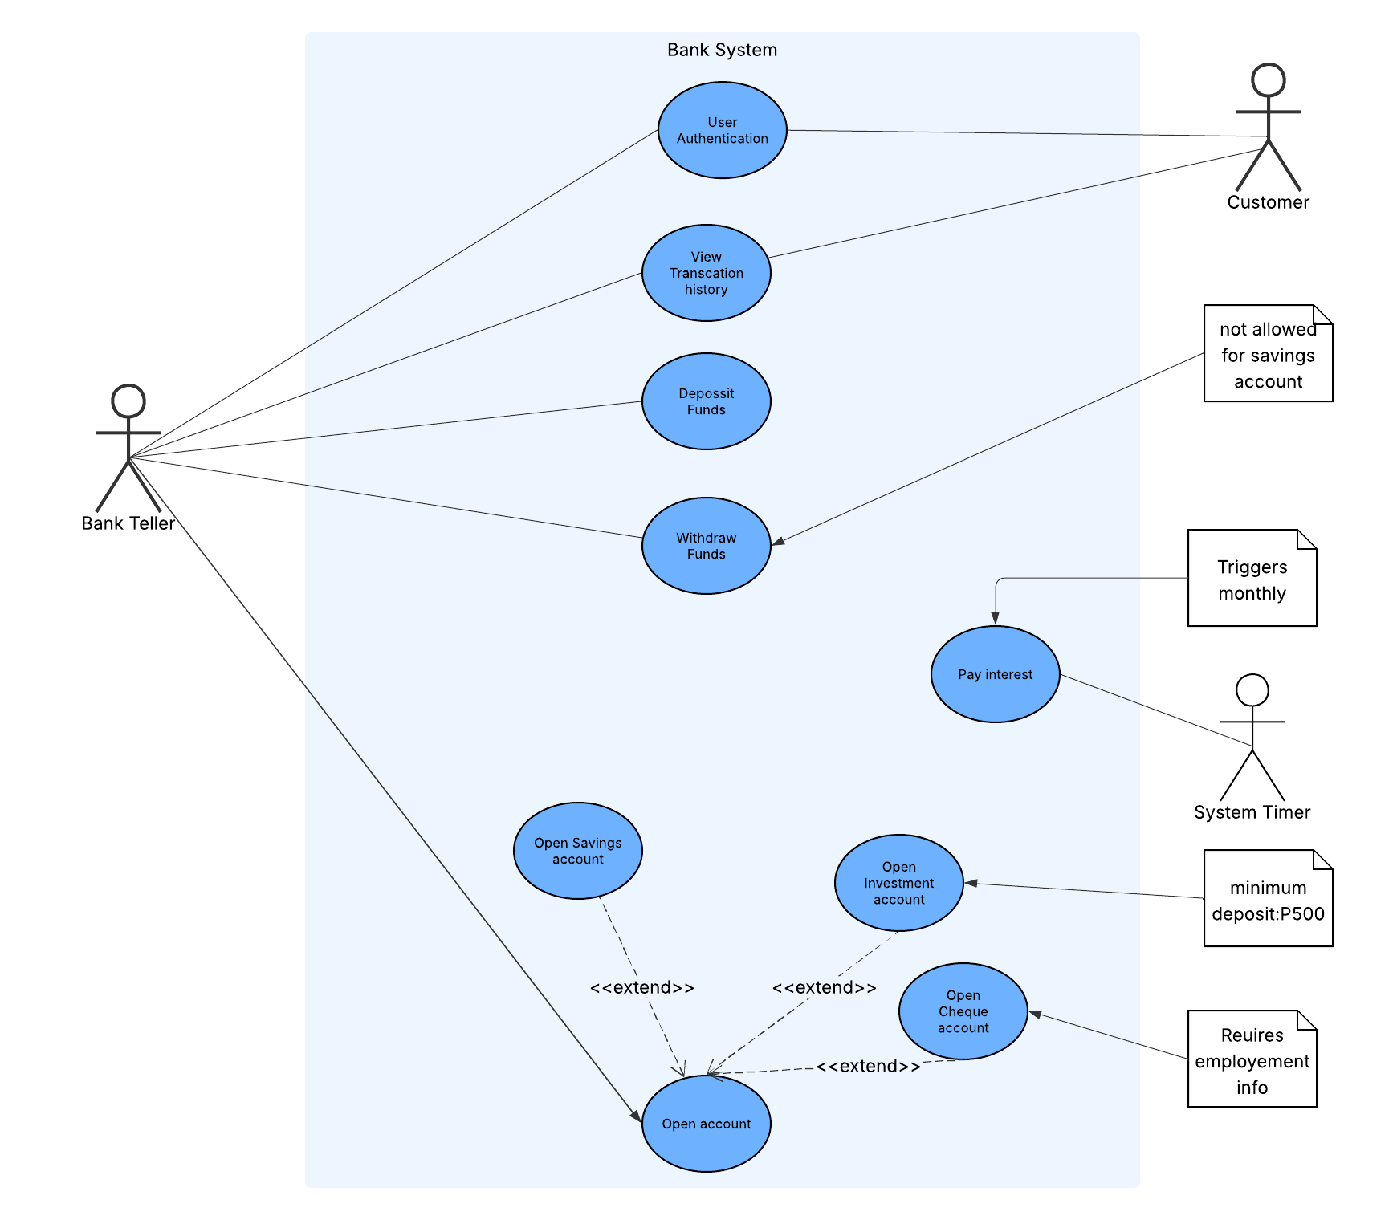

Class Diagram

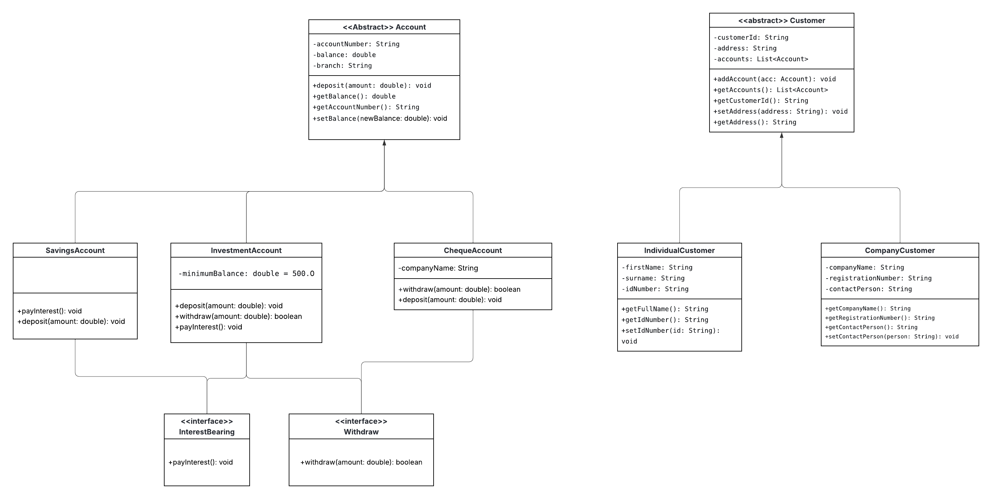

**Behavioral Diagram**

**Sequence Diagram**

**User Authentication Sequence Diagram**

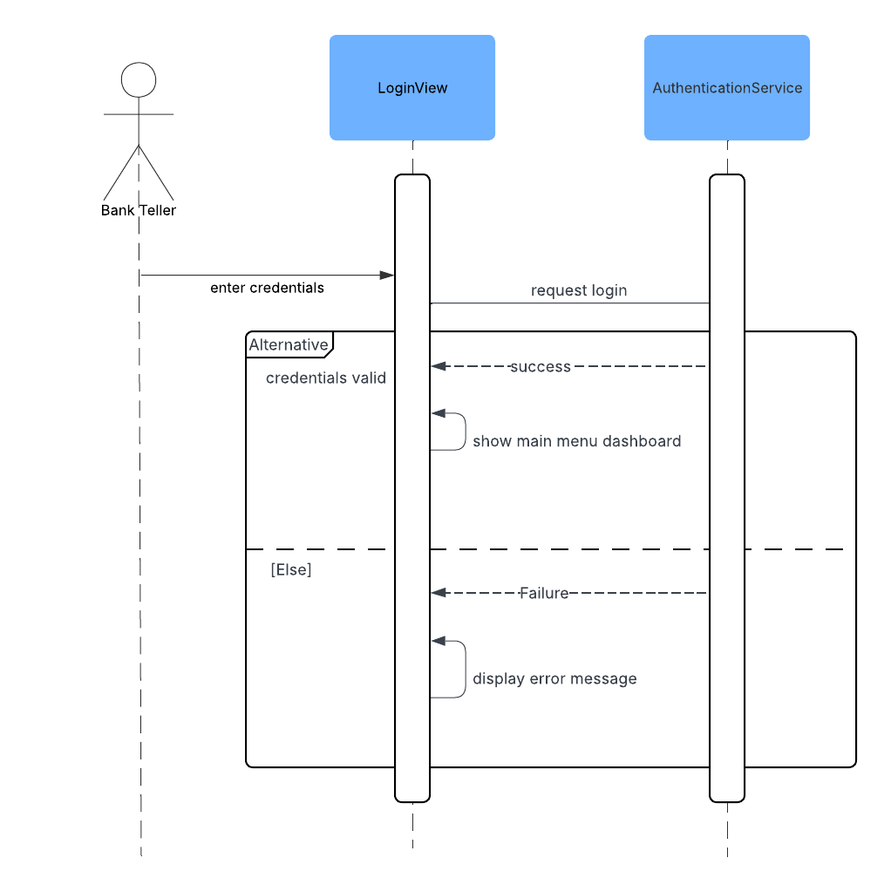

**Deposit Sequence Diagram**

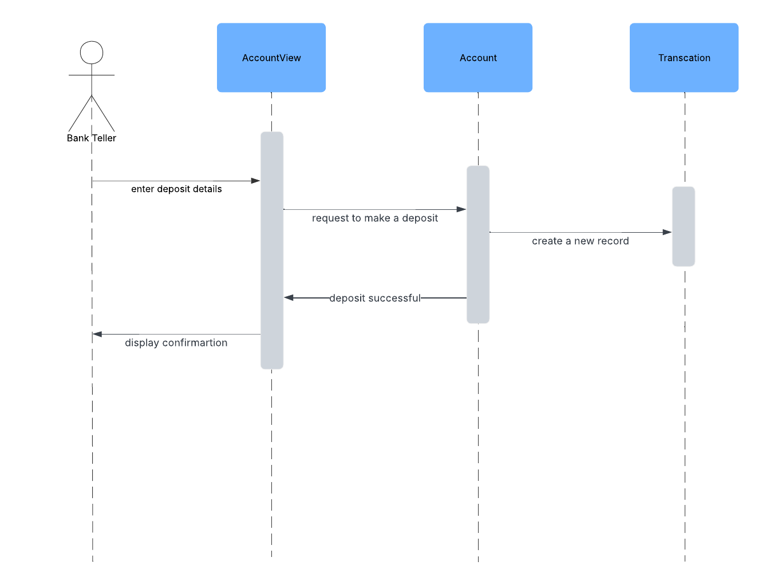

**State Diagram**

